Improvement Support to Councils - One Public Estate

Purpose:
For information.

Summary
The One Public Estate (OPE) programme has grown since its inception as a pilot programme in 2013, working with 12 council areas, to a large national programme encompassing 97% of local authorities.
This report details the growth and progress of the programme and provides details of the Phase 8 grant awards to local authorities.

Recommendation
That IIB notes the progress of the One Public Estate programme.

Contact officer: Ellen Vernon
Position: Programme Director – One Public Estate
Phone no: 07464 652918
Email: ellen.vernon@local.gov.uk

Improvement Support to Councils - One Public Estate
Background
- The One Public Estate (OPE) programme was established in 2013 and is jointly delivered by the LGA and the Cabinet Office through a blended team, half working in the LGA and half in the Office of Government Property (Cabinet Office). Since 2017 MHCLG have been an additional sponsoring partner.

- The OPE programme aims to support public bodies to identify and release surplus land, with a particular emphasis on repurposing such public land for housing and economic uses.

- The programme provides practical and technical support, alongside revenue and capital funding. To date the programme has administered eight rounds of funding totalling c.£57m of revenue funding (OPE) and c.£65m of capital funding (the Land Release Fund, LRF).

- The One Public Estate (OPE) programme is currently supporting MHCLG to design and develop approaches to administering future funding to support the delivery of housing on surplus local authority land.

One Public Estate Programme Structure
- One Public Estate operates through a structure of 72 local OPE partnerships. Local authorities act as the accountable bodies for these OPE partnership, convening a variety of public bodies in the locality in order to collaborate on public property matters.

- The public bodies involved vary by locality, depending on property ownerships and local ambitions, but typically involve blue light bodies, health bodies, central government departments with a local presence (DWP, MOJ, MOD et al) alongside local authorities.

- Each OPE partnership sets a programme of work to review public property needs collaboratively, in order to identify opportunities for colocations, public service hubs, and other efficiencies, in order to release surplus public land for housing and regeneration purposes. Partners benefit from capital receipts and revenue savings where surplus land can be repurposed, as well as improved public service delivery. Local authorities also benefit from the ability to repurpose public land to meet local housing needs.

- In addition, the network of OPE partnerships plays a helpful role connecting central government to local areas. Over the last year this has included:

  - supporting response and recovery in relation to the pandemic: for example, supporting property searches for response infrastructure
  - providing intelligence to the IPA (Infrastructure and Project Authority) about the public sector construction pipeline
  - providing early views to MHCLG on policy direction in relation to public land.

One Public Estate Support
- The One Public Estate offer includes financial support, peer support, plus practical and technical advice and brokering from the OPE team.

- OPE provides revenue support to early-stage property projects which involve an element of collaboration between local and central government. OPE grants typically fund feasibility studies, masterplans and other technical studies, plus local authority capacity.

- To date the programme has administered eight rounds of OPE revenue funding totalling c.£57m and supporting c.700 projects.

- LRF provides capital support, to local authorities only, typically funding the capital works that are required to bring a local authority owned potential housing site to a point of viability, and therefore deliverability. Typical works funded include: abnormal costs related to contamination, demolition of obsolete buildings, abnormal utilities costs, highways requirements and so forth.

- To date the programme has administered two rounds of LRF capital funding totalling c.£65m and supporting c.140 projects.

One Public Estate Delivery
- To the end of July 2020, the OPE programme has enabled the delivery of:
  - over £383m in capital receipts
  - over £76m in revenue savings to benefit public bodies
  - the release of surplus public land for over 15,500 homes
  - the creation of 25,000 jobs.

- Equally as valuable have been the softer benefits. These include:
  - enabling local authorities to control the supply of some land for housing
  - the ability to support SME’s and local supply chains
  - enabling local authorities to connect and engage with harder to reach parts of government
  - the ability to share problem solving and best practise between councils and other public bodies
  - the ability to link public property to place agendas – for example town centre regeneration.

- Case studies of OPE and LRF supported projects are attached at Appendix A.

One Public Estate – Phase 8 Awards

- Phase 8, which included a £10m OPE revenue offer, and a £20m LRF capital offer, was available for bidding between September and November 2020. Bids have now been assessed and are in the process of being awarded to councils.

- Appendix B, a more detailed pack of information regarding Phase 8 awards will be provided to IIB members on March 5th, as at the time of drafting this report the awards are yet to be announced by MHCLG’s Secretary of State and Cabinet Office’s Minister of State.

Issues
- None - there are no specific issues to raise in relation to the OPE programme.

Implications for Wales
- None – the OPE programme only covers English local authority areas. The OPE programme has previously engaged with Welsh Government colleagues to share experiences and learnings.

Financial implications
- The OPE programme is delivered by the LGA in partnership with Cabinet Office through a ‘time and materials’ contract. The current contract encompasses the period April 2019 through to March 2022. A contract for the period April 2022 onwards will be renegotiated with Cabinet Office during Q1/Q2 21/22.

Equalities Implications
- Support from the OPE programme, both financial and practical, is available to all English local authorities. The OPE programme encourages local authorities to develop innovative and creative projects to rationalise public property in order to best meet their local needs, and encourages partners to use approaches most appropriate for their locality. OPE does not have a ‘one size fits all’ approach to the projects it supports.

- From a programme team perspective, the OPE programme seeks to recruit and develop a diverse team with a variety of skills, backgrounds and experiences, and to ensure an inclusive working environment.
Next steps
- The OPE programme continues to work with OPE partnerships to support the delivery of property projects through to delivery.

- The OPE programme is exploring options to work more closely with private sector stakeholders, in particular the scope to introduce commercial income to the programme/delivering partners.

- The One Public Estate (OPE) programme is currently supporting MHCLG to design and develop approaches to administering future funding to support the delivery of housing on surplus local authority land. Further updates may be able to be provided in the near future.

APPENDIX A – ONE PUBLIC ESTATE and LAND RELEASE FUND CASE STUDIES
One Public Estate Phases 1-7
The York Central Development

- Planning permission approved for the infrastructure work that will deliver 2500 homes, 6500 jobs and 1.2m sq ft commercial development space.
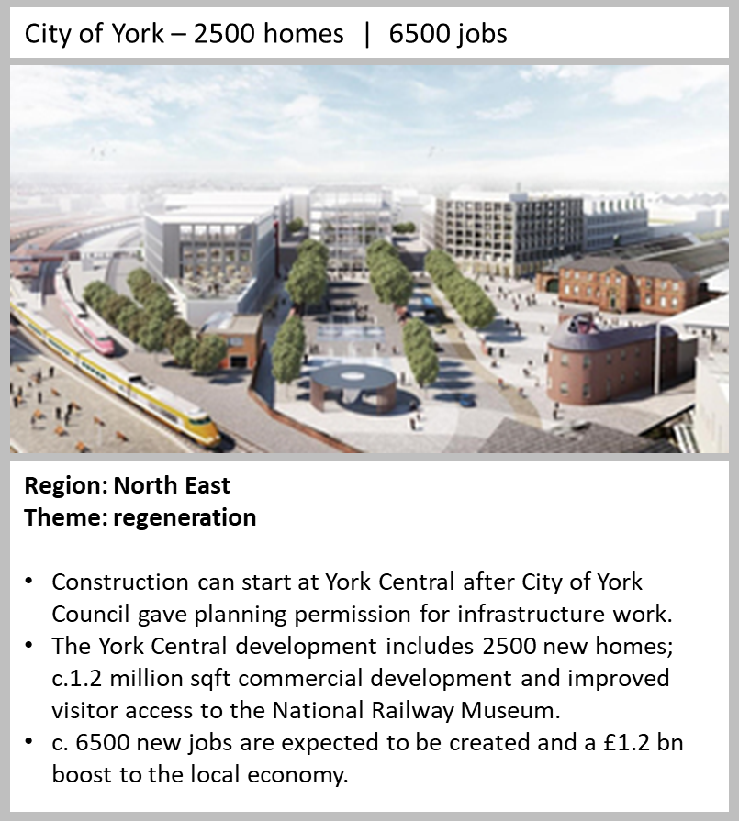

Chatham, Medway
- The development at White Road has progressed to 20 MMC homes on site and a capital receipt of £2.8m has been reported.
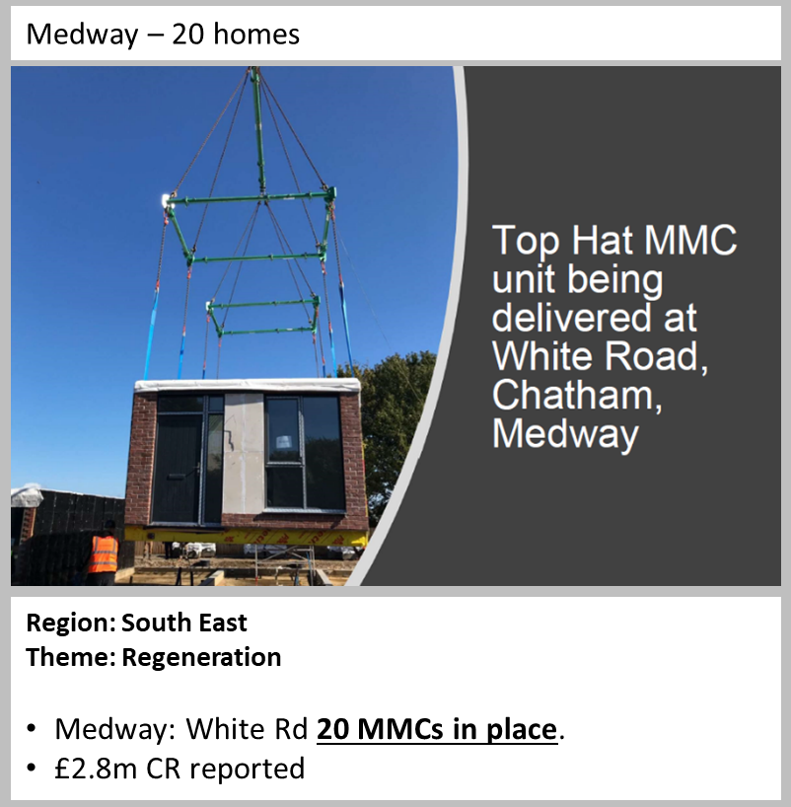

Wareham relocatable housing

- 18 homes have been delivered at the community-based project through a relocatable housing solution that supports affordable key worker accommodation.

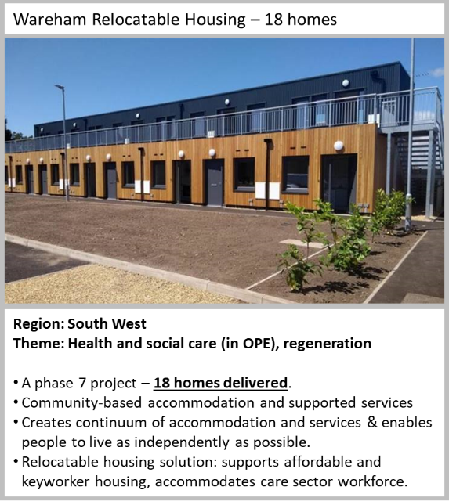

Worcestershire JPV integrated public services

- 5 sites sold resulting in a capital receipt of £7m and reduced running costs of £9m.

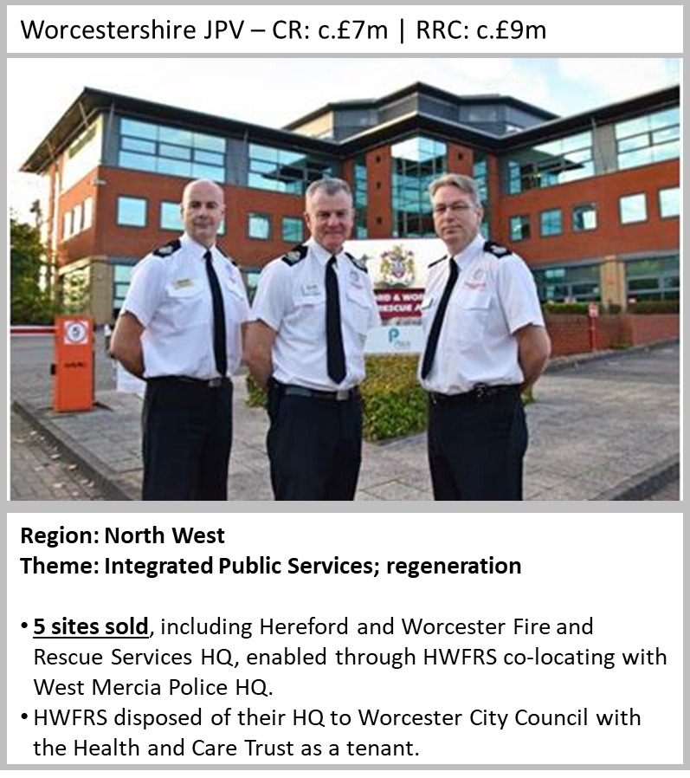

Hounslow Cavalry Barracks

- Development partnership with Inland Homes agreed, a key milestone for a project due to deliver in excess of 1000 new homes and £50m capital receipt.
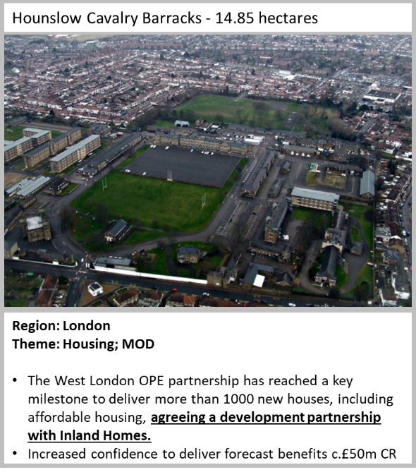

Land Release Fund Round 1

Hertfordshire OPE Partnership - Stevenage - 30 new homes over 2 sites

- Gresley Way - 15 new homes completed. Re-named Blackwell Close, this scheme comprises 14 homes for affordable rent and 1 for private sale. Stevenage District Council has collaborated with Hertfordshire County Council to let a proportion of the properties to clients with higher support needs, with properties designed to ensure they best met the needs of this client group.

- Burwell Court - 15 new homes completed. 15 one and two bed apartments which are entirely for social rent. The scheme was built on a derelict pub site that was a hot spot for anti-social behaviour, and has transformed the local area.

- Kenilworth Close - Construction started in October 2020 for the delivery of 236 homes by January 2024.

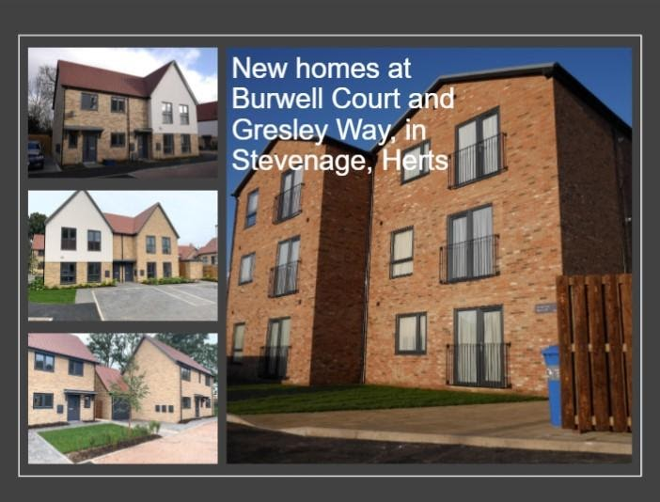

Plymouth OPE Partnership - Corporate Asset Release Project - 24 new homes

- St Budeaux Library site - 24 new homes completed. All are affordable homes, and four are wheelchair accessible. The site will eventually be part of a mixed development.

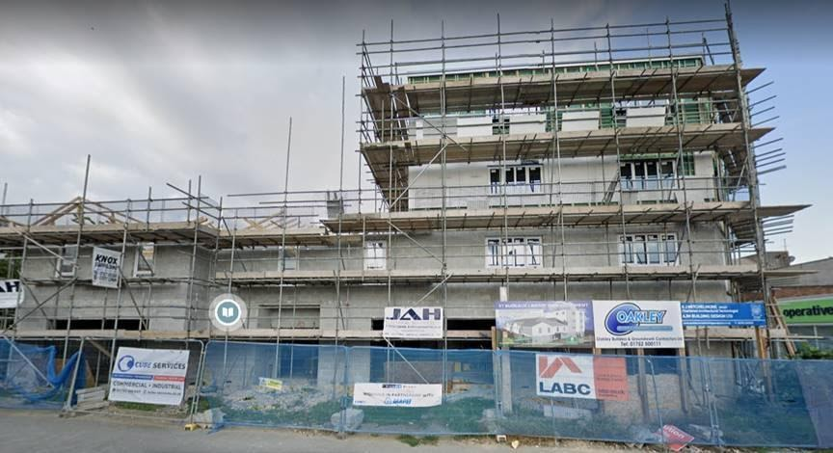

Essex OPE Partnership - Rochford - 14 homes construction start

- Rocheway and Millview sites - September saw construction start on 14 new homes in Rochford. Road infrastructure and drainage work commenced at Rocheway for the first phase of housing. This initial phase will deliver 14 homes, with a procurement exercise underway for the second phase (a further 60 homes).
